DIATOM HILL PROJECT
Esmeralda County, Nevada

MINING PLAN OF
OPERATION

To:
U.S. DEPARTMENT OF INTERIOR
BUREAU OF LAND MANAGEMENT
Tonopah Field Station
1553 S Main Street
P.O. Box 911
Tonopah, Nevada 89049

Sale Offered By:
AMERICAN DIATOMITE INC.
2533 North Carson Street
City of Carson City
State of Nevada 89706

REVISED
MAY 2013
DIATOMACEOUS EARTH
AMORPHOUS SILICA
MINING PROJECT
FOR SALE
FIGURE 0.0 NEVADA LOCATION MAP

TABLE OF CONTENTS

1.0 Summary---------------------------------------------------------------------------6
1.1 Report Scope----------------------------------------------------------------------6
1.2 Business profile--------------------------------------------------------------------7
1.3 Product Overview----------------------------------------------------------------7
1.4 Diatomaceous Earth Approved Potable Water Technology------------8
1.5 Historic Overview----------------------------------------------------------------8
1.6 Project Operation Overview---------------------------------------------------9
1.6.1 Mining---------------------------------------------------------------9
1.6.2 Mineral Processing----------------------------------------------10
1.6.3 Reserves and Production Schedule---------------------------10
1.6.4 Infrastructure-----------------------------------------------------10
1.6.5 Processing Costs and Value per Metric Ton----------------11
1.6.6 Using Diatomaceous Earth to Make Pure Amorphous
Silica Feed-Stock -------------------------------------------------12
1.7 Company Profile and Responsible Personnel------------------------------13
1.8 Land Status and Property Ownership--------------------------------------13
1.8.1 Overview-----------------------------------------------------------13
1.8.2 Summary of Agreements----------------------------------------13
1.9 Miscellaneous------------------------------------------------------------------14
SATELLITE PHOTO of DIATOM HILL PROJECT -- ----------------------------16
Assets _----------------------------------------------------------------------------------------17

2.0 Project Overview--------------------------------------------------------------20
2.1 Project Location and Access---------------------------------20
2.2 Environmental Study Area and Project Surface
Disturbance -----------------------------------------------------20
2.3 Project Implementation and Schedules-------------------20
2.4 Review of Other Permits and Approvals-----------------22
2.4.1 Federal Regulatory Framework----------------------------22
2.4.1.1 Plan of Operation and U.S. Mining Laws---------22
2.4.1.2 National Environmental Policy Act-----------------23
2.4.1.3 Federal Land Policy and Management Act-------23
2.4.1.4 Reclamation Plan Requirements--------------------24
2.4.1.5 Reclamation Cost and Bonding----------------------24
3.0 Geological Reserves-----------------------------------------------------------25
3.1 Production: Forward-Looking Statements-----------------------26
3.2 Risk Factors--------------------------------------------------------------27
3.3 No Operating History------------------------------------------------- 27
3.4 Phase 2: Pre-Feasibility Study Addendum------------------------27
3.5 Potential Cash Flow Summary for first stage pilot mill--------28

3.6 Silicon Prices-------------------------------------------------------------29

3. 7 Electric Power Plants--------------------------------------------------29

3.8 Diatom Photo------------------------------------------------------------31
3.9 References and Glossaries---------------------------------------------33
3.9.1 Glossary-------------------------------------------------------------------33
3.9.2 Certified Mineral Appraisal Valuation Report and Resume- 35
4.0 Certified Geology, Valuation and Resume------------------------40
4.1 Property Photos---------------------------------------------------------48
Table 1 Property Assets----------------------------------------------------------17
Table 2 First Stage Notice of Intent Permitting------------------------------21
Table 3 Second Stage Plan of Operations Permitting Schedule ---------21
Table 4 Summary of Second Stage Disturbance Area----------------------21
Table 5 Raw Geological Reserves before Deductions for Losses---------26
Table 6 Mineable Surface Reserves--------------------------------------------26
Table 7 Potential Cash Flow Summary----------------------------------------29

Figure 0.0 Nevada Location Map-----------------------------------------2

Figure 1.0 Nevada Facts---------------------------------------------------19

1.0 Summary;
DIATOMACEOUS EARTH PROPERTY FOR SALE,
American Diatomite Inc. “ADI” may own one of the largest known ultrapure Diatomaceous Earth (DE) Amorphous Silica mineral deposits in Nevada. Information from the United States Geological Survey “USGS” mineral and price data, and two independent certified registered mineral valuation companies were contracted for this report. ADI assets include: Proven Indicated Reserves: (192,000,000 Tons of High Purity DE Amorphous Silica valued at about ($75,840,000,000.00). Probable Indicated Reserves: 232,000,000 Amorphous DE Tons valued at about ($54,984,000,000.00). DE Amorphous Silica is non-carcinogenic and is one of the most useful elements known to man with over 7000 different market uses. The emerging worldwide energy shortage will have a major profound economic influence on the supply and demand for future DE silica products and energy production. The following is a summary of detailed information contained in the proposed Mining Plan of Operations (MPO) for production of DE and energy related products. ADI is proposing DE for the manufacture of Silica Feed Stock for (Electronics) (Solar Cells) Etc. (SiO2 → Si → H2 → Electricity). With the collapse of a monetary system minerals hold value worldwide. http://www.ks.uiuc.edu/Research/silica/
1.1 Report Scope;
This Mining Plan of Operation (MPO) will be submitted to the Tonopah Area Office of the U.S. Department of the Interior (USDI), Bureau of Land Management (BLM), in compliance with federal regulations regarding “Surface Management of Public Lands” under the U.S. Mining Laws stipulated by 43 CFR, Part 3800 (43 CFR Subpart 3809). American Diatomite Inc. (ADI) is proposing the sale, development and mining of diatomaceous earth (Amorphous Silica) minerals on public lands in the Monte Cristo mountain range, Esmeralda County, Nevada. The approved Notice of Intent, and pending Plan of Operations mining permit, known as the Diatom Hill Project, would result in development of one or more placer (surface) mining areas, construction of a loading pad, haul and access roads, and continued exploration activities. The MPO information contained herein describes the Diatom Hill Project proposed by American Diatomite Inc. (ADI), and environmental consequences that could result from implementation of these actions. The BLM may determine that an Environmental assessment Statement (EAS) would be necessary, as required by the National Environmental Policy Act (NEPA) (1969) if more than 5 acres are disturbed.
NOTICE PERMIT NUMBER IS AVAILABLE

1.2 Business Profile;
The Company...American Diatomite Inc. (ADI) was incorporated in the State of Nevada U.S.A., on October 10, 2001, and maintains its principal executive address at 2533 North Carson Street, City of Carson City, and State of Nevada 89706. The Company was incorporated primarily for the purpose of developing, mining and processing of Diatomaceous Earth (DE).
Exploration activities consist of 1700 acres of Federal (BLM) land located in northern Esmeralda County, Nevada U.S.A. Surface deposited pure white DE Silica is exposed in full view over several miles and measured up to three hundred feet in height and depth. (Deposited on the surface, open for full view inspection) The DE specialty silica mineral assayed as one of the purest grades of fresh water specialty DE silica minerals available at 89.3 percent silica (about 99.999% pure silica after leaching) as well as easy surface removal. (No underground mining)
Over 7000 markets for silica are known including, Industrial filtering of municipal water supplies, cattle feed, absorbents, fine fillers, insect control, hazardous earth absorbents, specialized amorphous silicon for solar cells, electronics, and production of filter products. The Bureau of Mines reported diatomaceous earth silica operations as the most consistent and productive mineral producers in Nevada operating consistently for over 80 years.
ADI intends to sell the Diatom Hill project and contract for the buyer to build a first stage De silica leach pilot mill processing plant for solar cell production. First stage pilot mill will prove the potential of sales in the energy sector. The value of specialty amorphous silica technology is about a 150/200 billion dollar a year industry and has led to a potential trillion dollar industry, “Georgia institute of technology SOP”.
The proven reserves and superior quality of the Company’s multibillion dollar tangible mineral asset, positions buyer for market control and high growth into the 21st century, and beyond. The Diatom Hill amorphous silica mineral property is a wholly owned project of ADI.
1.3 Product Overview;
Diatomite is white chalk-like in color, soft, friable, earthy, very fine-grained, siliceous, fossilized sedimentary rock. Diatomite also called kieselguhr or Tripolite are single cell microscopic sized plants (1 to 6 micron) and are a mineral of vegetable origin (plankton). There are several varieties of diatoms that lived close to the surface of the now extinct freshwater lake. Alive, they are at the base of the food chain. After death, they drop to the lake bottom and leave a micron sized hollow fossilized skeleton of pure amorphous silica with highly symmetrical perforations (Holes) known as a frustule. (See photo at end of document)
1.4 Diatomaceous Earth Approved Potable Water Technology;
In December 6, 1998 the EPA using the guide lines of the Interim Enhanced Surface Water Treatment Rule (IESWTR) approved DE as a superior municipal filtration technology for compliance with the SWTR. DE filtration is rated at the top of the list when considering microbial removal, capital costs, operating cost and ease of operation. In its final comments the EPA notes that DE is “very effective” for the removal of Giardia and Cryptosporidium from municipal drinking water systems. "The EPA rule opens the door for IMF financed public water systems (Worldwide) to incorporate DE as the main cost efficient filtration systems.” All DE mineral used in filtration water systems must be replaced regularly creating continuing sales.

1.5 Historic Overview;
The Diatom Hill Project area is located about 16 miles north of Coaldale Junction. Coaldale Junction is located about 45 miles north via highway SR 95 from Tonopah, Nevada U.S.A.
Prior to purchase of the mineral claims, American Diatomite Inc. performed extensive State Of The Art mineral exploration techniques to evaluate the potential depth and economics of the surface exposed high-grade DE mineral. Additional volcanic covered silica reserves were explored and proven to be contiguous with the surface exposed DE mineral.
American Diatomite Inc. significantly advanced the permitting process by conducting preliminary baseline studies, magnetometer studies, qualitative/quantitative sampled, re-logged surface samples, completed a geological block model and finalized mineral reserve calculations. American Diatomite Inc. staff had also developed a surface bench cut mining design and carried out preliminary engineering and economic evaluations. An independent due diligence feasibility study for the Diatom Hill Project was performed in 2005, and found the mineral testing and mine design results favorable.
1.6 Project Operation Overview;
1.6.1 Mining;
Mineral examiners determined the DE mineral claims to be legally "located" and therefore its mining methods must comply with BLM regulations for mining on public land (43 CFR 3809, Surface Management Regulations). Implementation of ADI proposed action would result in construction of one or more surface open cut bench areas and associated construction of loading pads.
Proposed DE milling and silica leaching processing and warehousing could be located on private lands and would not be subject to the Bureau of Land Management policy.
Mining and reclamation activities are expected to extend well beyond the projected 20-year mine federal permits. Additional mineral exploration during the 20-year federal permits will result in proving up the additional estimated 250 million tons of probable indicated reserves, which are covered by shallow volcanic flows. Additional proven indicated reserves will extend the mine life beyond the current 292,000,000 tons of proven indicated reserves and would require a revision to the MPO and additional National Environmental Policy Act (NEPA) analysis.
Total land associated with the initial first phase proposed DE silica pilot mill is approximately 85 acres. This acreage includes approximately 5 acres of BLM-administered public land for mining and 80 acres of private land for milling operations to be purchased by ADI. Second stage proposed action will include about 198.5 acres. All Federal BLM managed areas disturbed by the Diatom Hill Project would be reclaimed in accordance with the reclamation plan submitted by ADI to the BLM and NDEP.

1.6.2 Mineral Processing;
Mineral mined from the Diatom Hill project could be processed at the proposed Processing Mill Facility. The first pilot phase of operations will process about 25 tons of amorphous silica per day. Pilot mill operations allow ADI to produce cash flow and establish new markets for the amorphous silica while waiting for final MPO permits and second stage mill construction. The DE would be milled, leached, calcined, sized, bagged, and warehoused annually for final distribution to markets.
1.6.3 Reserves and Production Schedule;
ADI owns a world class Diatomaceous Earth mineral deposit of 192,000,000 tons of Proven indicated and 232,000,000 tons of probable indicated. The Company intends to continue exploration activities within the project area to prove up the additional 232,000,000 tons of Probable Indicated high-grade DE silica mineral and additional known reserves.
With continued exploration and documentation of the company asset under the volcanic cover, ADI could potentially own the world’s largest known high grade Diatomaceous Earth silica deposit. Prior to the development of the Diatom Hill project the total world reserve base was estimated by the U.S. Bureau of Mines to be almost one billion metric tons (MT) and of the one billion Mt; 250 million known tons (Mt) are in the U.S. (Antonides, 1999). (Bureau of Mines USGS)
First stage pilot mill will process about 25 tons per day of high grade amorphous silica. The second stage proposed production schedule calls for mining and processing about 300,000 tons of DE mineral annually (821 tons a day). About 300,000 tons of processed high grade 5N (99.999) pure amorphous specialty silica/silicon products could be reserved for the silica market and hydrogen production.
1.6.4 Infrastructure;
Infrastructure of the proposed first stage Processing Facilities would include mill buildings, milling equipment, loaders, fork lift, bag houses, pumps, acid storage tanks, leaching and precipitating tanks with agitator thickeners, centrifuges, granulation drying and packaging equipment, water reservoir ponds, reclamation of water and filters. Propane meeting regulatory standards for the amount of contained nitrous oxides would be used to provide heat for drying/calcining. Electrical generators and company vehicles would use propane fuel or unleaded gasoline. Mill processing water is to be secured from a local ground water source. All mining and trucking would be contracted out. The Processing Facility would be enclosed with a chain-link fence and patrolled to provide site security. Due to classified proprietary specialized silicon processing information, no flow sheet will be included in this report.
1.6.5 Processing Costs and Value per Metric Ton;
Mineral processing costs allocations for DE silica was reported by the USGS for the United States as averaging 10% for mining and trucking from mine to mill, 60% for processing, and 30% for packaging. A 2000 report stated energy costs were 25% to 30% of direct processing costs. The proportion of the DE product that is calcined and dried with propane gas directly affects energy consumption. Total direct mining and mill processing costs (fob processing facilities in Esmeralda County) will average about forty dollars per ton ($40.00) for filter amorphous silica products or leached product. Weighted average wholesale value per metric ton “as reported by the U.S. Geological Survey Minerals Yearbook 2010” was about $780.00 fob plant for specialty grade DE silica products. Using the Bureau of Mines Yearbook 2010 average price valuation for proven indicated specialty grade raw DE silica would be about $149,760,000,000. Current prices of pure filler grade DE for filtering applications are selling above $500.00 per short ton and above $25,000 for 5N (99.999) pure specialized amorphous silica (fob plant).
Processing costs for producing pure specialty amorphous silica will depend on the end products produced. The growth of the PV (Photo Voltaic) industry has resulted in an increased demand for silicon feedstock, the price of which has risen significantly. ADI has contributed to solving this problem by developing new processes for refining, and purification of amorphous silicon for metallurgical solar-grade silicon feedstock without using high temperatures.
“The 2011 contract price of polysilicon 9N (99.9999999) has dropped 100 percent in the last 2 years (2011) to ($200,000.00 per ton), and is anticipated to decrease more in 2012. Polysilicon vendors cannot keep up with huge OEM demand and are reportedly sold out of these materials for the next two years. The weighted average wholesale value of 5N (99.999) pure amorphous feed stock silica for manufacturing polysilicon has ranged from a low $5,000 and as high as $50,000 per ton FOB. 2011 retail prices of 5N amorphous feed stock silica decreased to about $25,000 per ton FOB China (2011) and prices are expected to decease more in late (2012). Silicon Gel - The retail price for a 25 Kg drum was about $800 (2007). (Bodman) 1-(610) 459-5600. Processing costs for producing 5N silica using the Soltech process for production of silicon will average about $500.00 per short ton.
1.6.6 Using Diatomaceous Earth to Make Pure Amorphous Silica Feed-Stock;
98% Silica Sand is the normal product for producing amorphous silica world-wide (Carcinogenic). Silica sand must be smelted at extreme high temperatures to extract the impurities to produce a 5N 99.999 amorphous silica product. ADI has developed a new leaching method for Diatomaceous Earth, which will produce high-grade 5N 99.99 pure amorphous silica without high temperature smelting. Expensive high heating or smelting of the naturally occurring amorphous DE silica mineral is not required to produce a pure 99.999 amorphous silica product. Inexpensive leaching products for manufacturing 5N silica gel can also be produced using salt to manufacture sodium hydroxide and chlorine. Leaching of silicon during the sodium hydroxide leaching process will produce a byproduct of hydrogen gas for generating power for the Nevada electrical grid (Green Energy) and a pure silica product for the silicon market.
Processing cost will average about $40.00 per ton for producing 5N amorphous feed stock silica with by-products of aluminum for the production of aluminum metal. The large size of the ADI tangible silica mineral reserves and the new silica/solar cell energy revolution suggest the Diatom Hill Project has the potential to be one of the largest suppliers of 5N amorphous silica feedstock and a major filter product producer.
1.7 Company Profile and Responsible Personnel;
The personnel responsible for managing the Diatom Hill Project and their mailing addresses are listed below. ADI directors are experienced in silica surface mining and hydrogen gas processing facilities and will assist in all related operations.

President | Treasurer / Operations Manager
Mr. Enick Wade | Darvin P. Wade
American Diatomite Inc.  2533 North Carson Street. | American Diatomite Inc.  Pahrump, Nevada 89061
Carson City, State of Nevada 89706.  Phone 1-310-538-5526  Email: enick@hotmail.com | 3431 Bond St.  Phone: 1-775-513-1576  Email: darvin@minessale.net

1.8 Land Status and Property Ownership;
1.8.1 Overview;
100% of the Diatom Hill mineral properties are owned and controlled by American Diatomite Inc. Federal mining claims is not subject to work commitments (other than annual maintenance fee payments, State and County taxes. Claim block identifications, ownership and acreage are summarized in Table 1. (Federal mining claims must be maintained annually)
1.8.2 Summary of Agreements;
American Diatomite Inc.: A purchase contract agreement between American Diatomite Inc. and shareholders was completed April, 2002 for the purchase of unpatented Federal mineral claims. The mineral claims are free from all liens and are not subject to overriding royalty payments. “SEE PURCHASE AGREEMENT”
ADI holds all mining rights to the Diatom Hill mineral property and is not subject to any royalties as discussed above. Preliminary Notice of Intent BLM permitting agreements have been finalized with the Bureau of Land Management and Esmeralda County Zoning for mining and production. (2009)
1.8.3 Miscellaneous; At the March 2004 EITF meeting of international accounting standards, the Task Force reached a consensus that mineral rights are tangible assets consistent with industry practice. With new amended Federal Accounting Standard Board (FASB) 141-1 and 142-1 guidelines and with new SEC rules that require State and Federal permits to be in place to operate, ADI will book 192,000,000 tons of proven indicated and 232,000,000 tons of probable indicated DE reserves as tangible assets. Hypothecating small portions of the DE assets could be used as Bank Collateral for securing large loans for startup projects, etc.
The American Diatomite Inc. Board of Directors has agreed to contract a DE silica pilot processing mill for the first stage of operations to place the Purchaser into “Legal production”. The first stage 25 ton day pilot mill and associated mining costs would be about $10,000,000 for amorphous 5 nines feed stock silica production. Proposed second stage 300,000 ton per year mill could cost up to $100,000,000 and would include production of 5 nines amorphous silica and filter by-products for filtering. All second stage mining and trucking could be contracted for about two dollars for mining and three dollars per ton for hauling ($3.00 if mill is close) without the initial up-front costs associated with leasing and purchasing mining equipment. Mining of surface deposited DE would include a dozer with rippers, scooping up the loose DE from the surface with a large front-end loader and loading into a truck for transport to mill. “Contract mining costs for surface DE mineral deposits are considered minuscule” More than half of all annual sales of silica products will be outside the United States. Dow Corning reported it recorded $45 billion in global sales in 2009 with a 10% increase in silica sales in 2010. Dow Corning is currently sold out of amorphous silica for the next two years. “2011”
Final Conclusions by the EPA Federal Regulations:
ACTION: Final rule.
40 CFR Part 180.1017 [OPP-2002-0031; FRL-6835-5]
Silica Amorphous, (Crystalline Free); Exempting silica amorphous, from the reporting tolerance will be safe. DE Amorphous silica is non- carcinogenic / Silica sand is considered carcinogenic “EPA”
"Silicon is arguably the 'gold standard' among electronic materials. Below is a diatom skeleton converted to silicon after heat treatment?
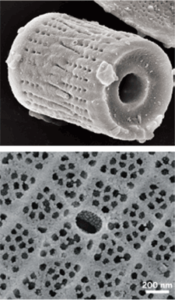
Reduction retains the lacy nanostructure of the diatom's shell.
The resulting rococo microstructures could find use in sensing, optical, electronic applications, solar cells, hydrogen gas generation, hydrogen gas storage and safe transportation.

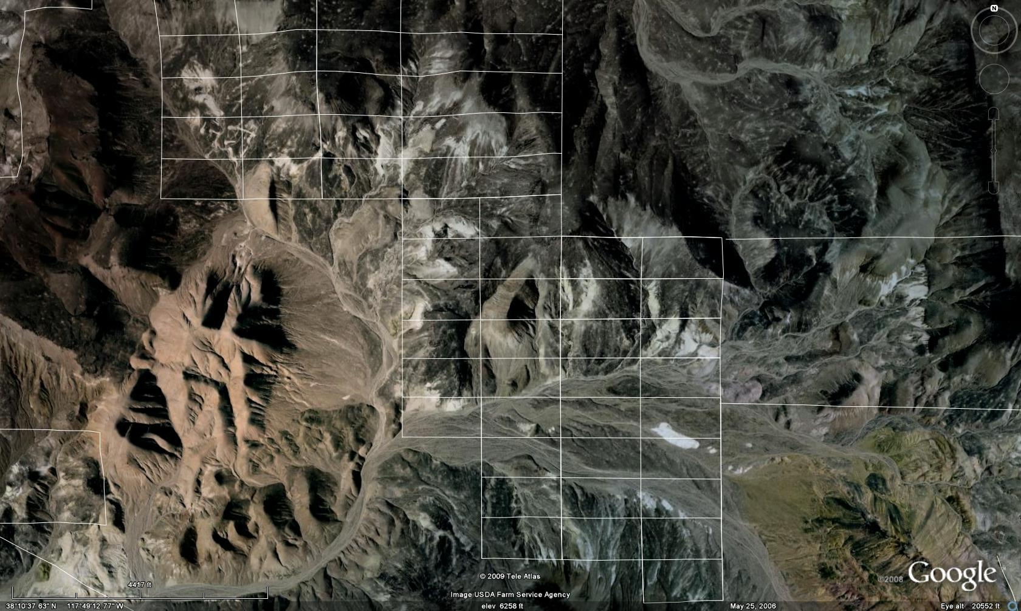
SATELLITE PHOTO of DIATOM HILL PROJECT

TABLE 1 / Exhibit C
 | America Diatomite Inc. Property Assets
 | Federal Mining  Claims | Original County Recorders Numbers | Claim  Reference | Approx.  Acres
 | Unpatented Claims
 | Diatom Hill
 | Federal Serial No.
 | #NMC 879910 | 161315 | White Rock -# 1 amended | 20
 | #NMC 879911 | 161316 | White Rock-# 2 amended | 20
 | #NMC 841156 | 157264 | White Rock 3 | 20
 | # NMC 857117 | 159351 | White Rock-4 | 20
 | # NMC 857118 | 159352 | White Rock-5 | 20
 | # NMC 857119 | 159353 | White Rock-6 | 20
 | # NMC 857120 | 159354 | White Rock-7 | 20
 | # NMC 866703 | 160137 | White Rock-8 | 20
 | # NMC 866704 | 160138 | White Rock-9 | 20
 | # NMC 866705 | 160139 | White Rock-10 | 20
 | # NMC 866706 | 160140 | White Rock-11 | 20
 | # NMC 866707 | 160134 | White Rock-12 | 20
 | # NMC 866708 | 160135 | White Rock-13 | 20
 | # NMC 825767 | 155599 | Diatom Hill-11 | 20
 | # NMC 825768 | 155600 | Diatom Hill-12 | 20
 | # NMC 82576 # NMC 825769 | 155601 | Diatom Hill-13 | 20
 | # NMC 825770 | 155602 | Diatom Hill-14 | 20
 | # NMC 825771 | 155603 | Diatom Hill-15 | 20
 | # NMC 825772 | 155604 | Diatom Hill-16 | 20
 | # NMC 869810 | 160278 | Cap 1 | 20
 | # NMC 869811 | 160279 | Cap 2 | 20
 | # NMC 869812 | 160280 | Cap 3 | 20
 | # NMC 869813 | 160281 | Cap 4 | 20
 | # NMC 869814 | 160282 | Cap 5 | 20
 | # NMC 869815 | 160283 | Cap 6 | 20
 | # NMC 869816 | 160284 | Cap 7 | 20
 | # NMC 869817 | 160285 | Cap 8 | 20
 | # NMC 869818 | 160287 | Cap 9 | 20
 | # NMC 869819 | 160288 | Cap 10 | 20
 | # NMC 869820 | 160289 | Cap 11 | 20
 | # NMC 869821 | 160290 | Cap 12 | 20
 | # NMC 869822 | 160291 | Cap 13 | 20
 | # NMC 869823 | 160292 | Cap 14 | 20
 | # NMC 869824 | 160293 | Cap 15 | 20
 | # NMC 869825 | 160294 | Cap 16 | 20
# NMC 958761 167619 Energy # 1000 20AC
# NMC 958762 167610 Energy # 1 20AC
# NMC 958763 167611 Energy # 2 20AC
# NMC 958764 165612 Energy # 3 20AC
# NMC 958765 167613 Energy # 30 20AC
# NMC 958766 167614 Energy # 31 20AC
# NMC 958767 167615 Energy # 32 20AC
# NMC 958768 167616 Energy # 33 20AC
# NMC 958769 167617 Energy # 34 20AC
# NMC 958770 167618 Energy # 35 20AC
Nevada Diatom # File Numbers

# NMC 953191 167357 NEVADA DIATOM #24 20AC
# NMC 953192 167358 NEVADA DIATOM #25 20AC
# NMC 953193 167360 NEVADA DIATOM #29 20AC
# NMC 953194 167361 NEVADA DIATOM #30 20AC
# NMC 953195 167362 NEVADA DIATOM #31 20AC
# NMC 953196 167363 NEVADA DIATOM #32 20AC
# NMC 953197 167364 NEVADA DIATOM #33 20AC
# NMC 953198 167365 NEVADA DIATOM #34 20AC
# NMC 953199 167366 NEVADA DIATOM #35 20AC
# NMC 953200 167367 NEVADA DIATOM #36 20AC
# NMC 1006349 # 0173207 NEVADA DIATOM #23 20AC
# NMC 1006350 # 0173208 NEVADA DIATOM #26 20AC
# NMC 1006351 # 0173209 NEVADA DIATOM #27 20AC
# NMC 1006352 # 0173210 NEVADA DIATOM #28 20AC
# NMC 1006353 # 0173211 NEVADA DIATOM #37 20AC
# NMC 1006354 # 0173212 NEVADA DIATOM #38 20AC
# NMC 1006355 # 0173213 NEVADA DIATOM #39 20AC
# NMC 1006356 # 0173214 NEVADA DIATOM #40 20AC
# NMC 1006357 # 0173215 NEVADA DIATOM #41 20AC
# NMC 1006358 # 0173216 NEVADA DIATOM #42 20AC
# NMC 1006359 # 0173217 NEVADA DIATOM #43 20AC
# NMC 1006360 # 0173218 NEVADA DIATOM #44 20AC
# NMC 1006361 # 0173219 NEVADA DIATOM #45 20AC
# NMC #1011717 #0176390 NEVADA DIATOM #60 20AC
# NMC #1011718 #0176391 NEVADA DIATOM #61 20AC
# NMC #1011719 #0176392 NEVADA DIATOM #62 20AC
# NMC #1011720 #0176393 NEVADA DIATOM #63 20AC
# NMC #1011721 #0176394 NEVADA DIATOM #64 20AC
# NMC #1011722 #0176395 NEVADA DIATOM #65 20AC
# NMC #1011723 #0176396 NEVADA DIATOM #68 20AC
# NMC #1011724 #0176398 NEVADA DIATOM #66 20AC
# NMC #1011725 #0176399 NEVADA DIATOM #67 20AC
# NMC #1011726 #0176400 NEVADA DIATOM #69 20AC
# NMC #1011727 #0176401 NEVADA DIATOM #70 20AC
# NMC #1011728 #0176403 NEVADA DIATOM #71 20AC
# NMC #1011729 #0176404 NEVADA DIATOM #72 20AC
# NMC #1011730 #0176405 NEVADA DIATOM #73 20AC
# NMC #1011731 #0176406 NEVADA DIATOM #74 20AC
# NMC #1011732 #0176407 NEVADA DIATOM #75 20AC
# NMC #1011733 #0176408 NEVADA DIATOM #76 20AC
# NMC #1069629 #0186645 NEVADA DIATOM #77 20AC M #NMC #1074025 #0187060 NEVADA DIATOM #46 20AC

TOTAL ACREAGE 1,740

PHONE NUMBERS TO CALL FOR DUE DILENGCE

Bureau of Land Management Phone: 775-861-6500 http://www.nv.blm.gov
P.O. Box 12000 (1340 Financial Blvd. 89502-7147) Reno, NV 89520-0006
Esmeralda County, Nevada Phone: 1-775 485-6337

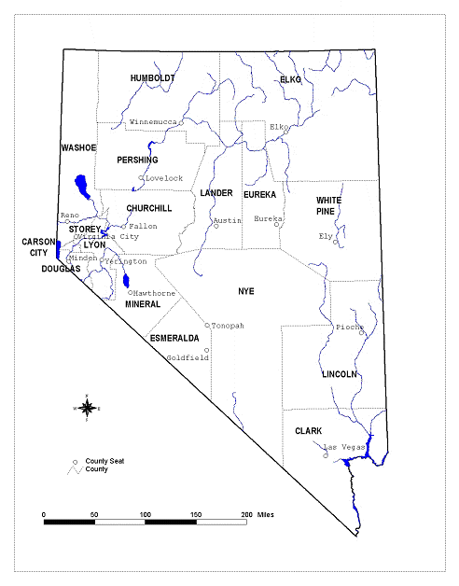
FIGURE 1.0 NEVADA FACTS
Area: 110,540 square miles (70,745,000 acres)
Population (year 2009) – 2,643,085
Average Population Density 2000: 18 persons per square mile
Highest Elevation: Boundary Peak – 13,140 feet (Esmeralda County)
Lowest Elevation: Colorado River – 470 feet (Clark County)
Average Annual Precipitation – 9 inches (statewide)
314 mountain ranges; 25 summits over 10,000 feet
232 hydrographic (groundwater) basins

2.0 Project Overview;
2.1 Project Location and Access;
The Diatom Hill project is located midway between the cities of Las Vegas and Reno, via SR-95 in the Monte Cristo mountain Range of Esmeralda County, State of Nevada. The Project area is accessible from SR 95 (State Route) by 7 miles of prior existing unimproved gravel road. Approximately 7 miles of this road would be re-graded and widened from about 10 feet to an overall width of 40 feet to accommodate safe passage of haul trucks and mine equipment. About 1 mile of new road construction would be required to access the mine surface open cut area from the existing unimproved access road. The Diatom Hill project lies within Sections 23, 25, and 26 of Township 4 North, Range 37 East, with an average top elevation of the Diatom Hill Project is about 6,100 feet above mean sea level.
2.2 Environmental Study Area and Project Surface Disturbance;
The Diatom Hill Project environmental study boundary and the immediate surrounding area will be directly impacted by the project. The study area would encompass approximately 306.5 acres and reflects 5 acres to be disturbed in the first phase pilot mill operation.
2.3 Project Implementation and Schedules;
First stage approved BLM Notice of Intent permits will be used for mining of raw silica product. Development of the production mill would begin with the completion of the first stage permitting effort, which is currently approved. Second stage primary permit requirements consist of an approval of a MPO, via an Environmental Impact Statement (EIS) by the BLM as well as an Aquifer Protection permit from the State of Nevada and Air Quality Permits from the Bureau of Air Quality-State Division of Environmental Protection. It is currently estimated that approval of all second stage permits will take 6 to 12 months from the start of the permitting effort. The tasks associated with this schedule are shown in Table 3 of this MPO and reflect an assumption that all permit applications required for the second stage project would be submitted during the completion of the draft EIS. In this manner, the agencies would be familiar with the Project and would be reviewing their respective permits at the same time they are required to comment on the draft EIS.
TABLE 2

First Stage Notice of Intent Permitting Schedule Was Approved And Reclaimed

ABOUT SIX TO EIGHT WEEKS FROM SUBMITTAL

TABLE 3
Second Stage Plan of Operations Permitting Schedule
Task | Time | Cumulative  Time
Prepare and Submit MPO
BLM Review of Completeness | 1 month | 1 month
ADI Prepare Application for Other permits | 2 months | 2 months
Prepare and Sign MOU | 1 month | 2 months
Publish NOI to Prepare EIS | 2 months | 3 months
Public Scoping | 1 month | 4 months
ADI Submit Applications for Other permits | 1 month | 4 months
Prepare/distribute draft EIS | 4 months | 8 months
Public Comment Period | 2 months | 10 months
Prepare/Distribute Final EIS | 3 months | 13 months
BLM ROD | 2 months | 15 months
Other Permits Approval | 6 months | 15 months

TABLE 4
Summary of Second Stage Disturbance Area
Project Component | Public Land (acres)  (unpatented claims) | Private Land  (Patented Claims) | State  Lease | Total
Diatom Hill 0pen Cut | 118. | 0 | 0 | 118.0
East Reject Dump | 10. | 0 | 0 | 10.0
East Diatom Hill Exploration | 1. | 0 | 0 | 1.0
Temporary Stockpiling / storage | 9. | 0 | 0 | 9.0
Roads/Buildings | 15. | 0 | 0 | 15.0
Sediment Control/Diversion | 1. | 0 | 0 | 1.0
Well Field/Pipeline | 4.5 | 0 | 0 | 4.5
Relocation of Roads | -- | 0 | 0
TOTAL | 158.5 | 0 | 0 | 158.5

In conjunction with the first stage permitting program, detailed engineering, project staff, together with outside engineering firms would perform procurement and contractor selection. First stage permits are approved and construction of the 25 ton per day mill could immediately commence. Individual subcontractors would be awarded for mine site preparation, processing equipment construction and buildings.
Additionally, mining equipment could be operated by subcontractors as a combination on-site mining, crushing and storage pad effort. Construction of pilot mill is scheduled to begin immediately upon securing financing from purchaser, and second stage mill completion is expected to take six months to one year or more.
2.4 Review of Other Permits and Approvals;
There are a number of Federal, State and local laws and regulations, which will require a permit or approval for the second stage Diatom Hill Project prior to construction and/or operation. Major permits and approvals are summarized below and are currently in progress.
2.4.1 Federal Regulatory Framework;
The BLM has a major Federal government role in reviewing and approving the proposed project. These BLM roles, along with other Federal agencies, are summarized below.
2.4.1.1 Plan of Operation and U.S. Mining Laws;
United States mining laws and the regulations by which they are enforced recognize the statutory right of a Federal mining claim holder to develop mineral resources on Federal lands. Because the Diatom Hill Project includes unpatented mining claims located on Federal land administered by the BLM, and will cause a surface disturbance of more than five acres in the second stage, a MPO must be approved for the proposed second stage project. BLM responsibilities for reviewing a MPO are spelled out in BLM regulations (43 CFR Part 3849; Surface Management under the General Mining Laws).
2.4.1.2 National Environmental Policy Act;
Submitting the second stage MPO to the BLM for the project will initiate the environmental analysis process as mandated by the National Environmental Policy Act (NEPA). As a prerequisite to approving or not approving the MPO for the project, the BLM must prepare an evaluation of the environmental effects of the proposed project in accordance with NEPA. The NEPA process is the decision-making tool, which will be used by BLM to determine potential impacts and mitigation measures to reduce impacts, and to identify any unavoidable impacts associated with the proposed project. For major Federal actions, which could significantly affect the quality of the human environment, NEPA requires that an Environmental Impact Statement (EIS) be prepared. BLM may determine that a separate EIS be prepared for public scoping at the Diatom Hill Project.
2.4.1.3 Federal Land Management and Policy Act;
BLM policies, plans, programs and responsibilities, based on the Federal Land Policy and Management Act (FLPMA) of 1976, recognize that public lands are an important source of the nation's mineral and energy resources.
BLM is responsible for making public lands available for a wide range of uses that include the orderly and efficient development of mineral and energy resources, recreation, and wildlife / fisheries conservation. If no unnecessary or undue degradation associated with the proposed Diatom Hill Project were found to exist by BLM, the proposed operation would conform to FLPMA requirements.
2.4.1.4 Reclamation Plan Requirements;
The Mining and Mineral Policy Act of 1970 (MMPA) states that the federal government should promote the "development of methods for the disposal, control, and reclamation of mineral waste products, and the reclamation of mined land. The mineral policy act would lessen any adverse impact of mineral extraction and processing upon the physical environment that may result from mining or mineral activities."
The BLM's long-term reclamation goals are to shape, stabilize, re-vegetate, or otherwise treat disturbed areas in order to provide a self-sustaining, safe, and stable condition that provides a productive land-use plan for the area. The short-term reclamation goals are to stabilize disturbed areas and to protect both disturbed and adjacent undisturbed areas from unnecessary or undue degradation.
BLM has prepared a Solid Minerals Reclamation Handbook to provide consistent reclamation guidelines for all surface-disturbing activities, including mineral activities conducted under BLM authority. BLM will review the Reclamation Plan for the Diatom Hill Project to ensure BLM's environmental protection responsibilities are carried out.
2.4.1.5 Reclamation Cost and Bonding;
To guarantee completion of project reclamation, a $16,000 dollar bond per 5 acres was required for the first stage notice of intent (based upon acreage to be disturbed). Bonding of reclamation procedures is required under various land management regulations, and BLM policy requires bonding for all approved mining operations on public land. Estimated costs of reclamation are proposed by mining companies using industry guidelines and standards for equipment, material, and Davis-Bacon Wage Rates for labor. These rates are standards used by BLM and NDEP to determine the bond amount. After approval, the final bond amount for the proposed project would be determined by BLM based upon the final design plans for the total acreage to be disturbed and the projected costs of closure and reclamation.
Nevada Division of Environmental Protection (NDEP) bonding or "surety" requirements for mine reclamation in Nevada are outlined in Nevada Administrative Code (NAC) 519A.350 - 519A.630 regulations. For BLM, the Surface Management Regulations (43 CFR 3809) establish bonding policy relating to mining and mineral development.
3.0 Geological Reserves;

As of October 2009, American Diatomite Inc. had pro forma proven indicated reserves of 192,000,000 tons of high quality Diatomaceous Earth and about 232 million tons of probable indicated DE mineral. Probable indicated reserves are covered with shallow volcanic flows. Large areas of the Diatom Hill Project are very visible and exposed with clean white DE rising in elevation up to 300 feet or more. These insight high quality DE mineral areas extend for several miles with easy access and would require little or no surface striping of overburden for economical mineral recovery.
The Diatom Hill reserves were calculated in tonnage by satellite within the two grade zones. Proven and indicated reserves are considered to be those blocks within the ranges indicated by the variograms: 2640 feet in the strike direction, 1,320 feet in the width direction and 100 feet in depth for the west high-grade zone and 300 feet in depth in the east zone. Three composites were also required for grade estimation. Total cubic feet were divided by a factor of 60 for weight in zones 1, 2 and 3 for estimating tonnage.
Proven indicated reserves were assigned to those mineral blocks within a search radius of 450 feet for both the high and lower grade. This reserve estimate excludes the DE mineral previously mined from surface and trenching operations. Table 5 & 6 lists a small portion of proven/indicated geological reserves located in the N.W of section 23.

TABLE 5
Raw Geological Reserves Before Deductions For Losses
Cut-off grade Proven Indicated  (DE) | Tons  Zone 1,2&3 | Average Grade  (D.E) | Contained, Clay, ash,  and 3% aluminum
89..3 | 5,621,333.33 | 89.3% | 10.7%
 | A-B-C-D-E-F
Proven Indicated | Zone 2
89..3 | 25,295,999.99 | 89.3% | 10.7%
Total | Zone 1 and 2
Proven indicated  Before Production Losses | 30,917,333.32 | 89.3% | 10.7%
Proven and Indicated Before Production Losses | Zone 3 161,082,666.68 | About 89.3% | 10.7%

TABLE 6
Minable Surface Reserves
Mineral Tons | Mineral Grade  (DE) | Trace Elements  and Volatiles (%) | Waste Tons | Strip  Ratio
Proven/Indicated 192,000,000. | 89.3% | 10.7% | 105,000 | .6
Probable/Indicated  232,000,000 | Surface assay  89.3%? | unknown% | unknown | unknown
Total Estimated Tons
424,000,000

3.1 Production; Forward Looking Statements;

The information contained in this document includes forward-looking statements within the meaning of Section 27A of the United States Securities Act of 1933, as amended, and Section 21E of the United States Securities Act of 1934, as amended, with respect to achieving corporate objectives, the Company's analysis of opportunities in the acquisition and development of this mining project interests and certain other matters. These statements are made under the "Safe Harbor" provisions of the United States Private Securities Litigation Reform Act of 1995 and involve risks and uncertainties which could cause actual results to differ materially from those in the forward looking statements contained herein.

3.2 Risk Factors;

An investment in the Ownership Interest IS highly speculative and involves substantial risks and uncertainties, including those stated below, which, are by no means, all-inclusive in nature.

In addition to the other information included in this Memorandum, you should carefully consider the following risk factors in evaluating the property, its business and its prospects before you purchase any Ownership in the DE Mineral Claims. The risks summarized below are not the only risks facing the Purchaser. This Offering is directed only to accredited purchasers who can bear the economic risk of their investment.

3.3 No Operating History; American Diatomite Inc. (The Company) is a new enterprise formed only for DE silica production and has no prior operating history. The Purchasers potential is dependent on access to its mineral project with approved permits and financing. The Notice of Intent was approved and BLM has stated that mining access will be allowed from date of approval of the Notice of Intent.

3.4 PHASE 2: Pre-Feasibility Study Addendum;

American Diatomite Inc. calculated results of a comprehensive review of the 2010 Pre-feasibility Study (The “Pre-feasibility Study” of its 100% Owned Diatom Hill Mineral Project) (The “Addendum”) located in the State of Nevada, USA. The Addendum prepared by Darvin Wade reflects recent changes in economic conditions in the US and opportunities identified in the Pre-feasibility Study to reduce both capital and operating costs. A total proven indicated and probable indicated DE mineral reserve base of four hundred and twenty four million tons (424,000,000). A proposed first leach stage Pilot production rate of 9,125 tons per year and a second stage five nines 99.999 production rate of 300,000 tons of pure silica product per year.
A summary of the high lights of the Addendum is shown below.

3.5 Potential Cash Flow Summary for first stage pilot mill;

TABLE 7

Potential Cash Flow Summary
A- Total Geological Resources@ 89.3 percent Amorphous Silica

PROVEN INDICATED & PROBABLE: 424,000,000 tons @ 89.3% raw silica.
________________________________________________________
360,400,000 Tons of raw unprocessed Specialty Silica Recovered After 15% Losses.

________________________________________________________
B- First Stage 5 Nines (99.999) Production of Amorphous Silica.
Initial Capital Cost (millions) US - $10,000,000.00
25 Ton per Day Production Rate 365 days Maximum, 7,756.25 Tons Recovered After 15% Losses from Leach Processing with Purity of 99.999 5N “FOB” Valued At $7,000 per Ton. Will Gross “$54,293,750.00” Does not include sale of filter products or aluminum byproduct.

B- 5 Nines “99.999” Pure Amorphous Silica Production
Initial Capital Cost (millions) US - $100,000,000.00 Plant Capacity 300,000 Tons per Year
Economic Performance for First Year Production of Amorphous Silica 99.999 Feed-Stock Material at 300,000 Tons per Year, With a Recovery Rate of 255,000 Tons After 15% Processing Loss.
_____________________________________________________________
Cash operating Costs = 300,000 tons Per Year X (US $40/ Ton):
_________________________________________________$12,000,000.00
Gross Rate of Return @ US $7,000 per Ton X 255,000 Tons of
Amorphous Silica with a purity of 99.999_”FOB $1,785,000,000.00 Net Present Value (Millions) @ US $7,000 Per Ton X
255,000 Tons of Recovered SiO2 after mill Deductions $1,774,800,000.00
Projected Life at 300,000 tons per year divided into 192,000,000 proven indicated reserves = “640 Years”
C- Production of DE Silica Feedstock and filter products costs are a function of fuel, operation and capital costs. Average cost is about $40. per Ton FOB.

American Diatomite is offering three Business Plans for purchaser:
1-Installation of a 25 ton per day pilot mill as a first stage investment of $10,000,000.
2-Installation of a 821 ton per day leach mill as a second stage investment of $100,000,000.
3-Mining and shipping of raw DE product with an investment of $2,000,000.00
3.6 Silicon Prices; In August 2010, spot prices reached $56.1 per kilogram and will continue to rise, according to a recent Solar Spot Price Survey from BNEF. Silica feed stock 98%=$2,900. Per ton. Silicon feed stock 99.999% =$7,000.00 per ton.
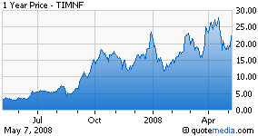
Regular grade silicon (99.5%) sold for about $30/kg 2008. The average Solar Grade Silicon 6N (99.9999%) pure has fallen to $67 per kilogram in the second quarter of 2009 ($60,909.09 Per Short Ton). Hyper-pure 7N (99.99999) silicon is available at a much higher cost. Silicon prices are expected to drop as new manufacturing processes are developed.
American Diatomite Inc. has developed a unique process for manufacturing solar grade Silicon at a production cost of around ¢.25-¢.50 cents per kilogram, compared to a production cost of $25-30 per kilogram via a typical Siemens plant. 1 kilogram =2.2 pounds.
3.7 Electric Power Plants; Electricity production costs are a function of solar cell costs, maintenance, and capital costs.
FERC has issued two related rules (Orders 888 and 889) designed to bring low cost power to consumers through competition, ensure continued reliability in the industry, and provide for open and equitable transmission services by owners of these facilities. Specifically, Order 888 requires open access to the transmission grid currently owned and operated by utilities. The transmission owners must file nondiscriminatory tariffs that offer other suppliers the same services that the owners provide for themselves. Order 888 also allows these utilities to recover stranded costs (investments in generating assets that are unrecoverable due to consumers selecting another supplier). Order 889 requires utilities to implement standards of conduct and an Open Access Same-Time Information System (OASIS) through which utilities and non-utilities can receive information regarding the transmission system. Consequently, utilities are expected to functionally or physically unbundle their marketing functions from their transmission functions.
http://www.energy.gov/energysources/electricpower.htm
http://www.eia.doe.gov/cneaf/electricity/epm/epm.pdf.
http://www.eia.doe.gov/
Short-Term Energy Outlook
Annual Energy Outlook
International Energy Outlook

http://www.energy.gov/

In June 2009, retail sales of electricity decreased 7.3 percent compared to June 2008. This decrease in retail sales was caused mainly by the significant decline in industrial consumption as observed by the 14.6-percent decrease in industrial retail sales over the same period. The average U.S. retail price of electricity decreased 1.0 percent in June 2009 compared to June 2008. While decreases in the average U.S. retail price occurred in the commercial, industrial, and transportation sectors, the average residential retail price did increase by 0.6 percent from June 2008 to June 2009.

3.8 Diatom Photo;
Diatom converted to silicon at 650 ºC. (Contains No Oxygen)
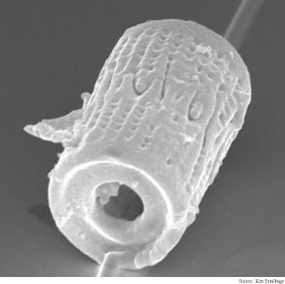

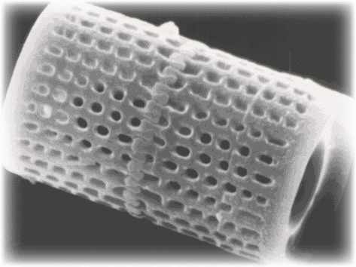 | Diatom Skeleton  Magnified by Electron  Microscope

3.9 References and Glossaries;
3.9.1 Glossary;
The following glossaries are used throughout this report:
Amorphous silica: Or non-crystalline (without form), is usually prepared by vapor-phase hydrolysis, precipitation or other processes that ensure the absence of crystalline free silica. Three forms of synthetic amorphous silica are classified according to their method of preparation: silica gel (silica G), precipitated silica (silica P) and fumed silica (silica F). Fumed silica and silica fume are (thermally generated).There is a natural occurring amorphous silica, namely diatomaceous earth. (Non-Carcinogenic) All types of amorphous silica can be converted to crystalline forms of silicon for hydrogen production and solar cells (polysilicon) when heated to a sufficiently high temperature.
BLM: Bureau of Land Management
Carbothermal-nitridation: Production of Non oxide silicon products using heat, carbon and an atmosphere of nitrogen.
Diatom: A microscopic unicellular plant which has an envelope (frustule) or outer skeleton of hydrated amorphous silica, close to opal in composition, and usually in two parts, though some have a ring or tube shaped frustule and these grow in chains. They inhabit both fresh and salt water.
Diatomaceous Earth: A siliceous fossil accumulation of diatoms.
Kriging: Geostatistical estimation techniques-based on a study of the spatial variability of the DE mineral deposit as reflected in the semivariogram which allows calculation of a measure of the error associated with the grade estimates, namely the variance of the error distribution.
Lacustrine: Diatomaceous Earth deposits that have been accumulated in an extinct freshwater lakes or marshes.
M P O: Mining Plan of Operation

Polysilicon: (p-si) is short for Polycrystalline Silicon, which is a form of silicon composed of many crystalline crystals, as opposed to Amorphous Silica (a-si), which is an unordered form with a random internal structure (Non Crystalline). Polysilicon is grown using amorphous silica. Making an LCD requires the 99.999 amorphous silicon to be converted to pollysilicon by laser, deposited on transparent material (the substrate). Depositing polly-silicon proved to require too high a temperature (typically 650 deg plus) to make it a practical proposition, so attention switched to amorphous silicon which could be deposited at a much lower temperature (380 deg) allowing glass to be used as the substrate. Laser crystallization of amorphous silicon to polysilicon is the primary method used for creating poly-Si films at low-temperature.
Seven Nines: Theoretically an absolutely pure Si element is not obtainable and the term is applied in practice to Si metals of high purity for solar cells and other electronic uses.
Silica: Dioxide of silicon (Silicon combined with oxygen)
Silica Sand: “Carcinogenic” Very high in SiO2, hence a source of silicon. Not to be confused with amorphous silica, which is non-carcinogenic?
Silicon: The most abundant element next to oxygen in the earths crust. (Silicon without oxygen)
View web site below for prices.
http://www.tradekey.com/kb-polysilicon/ http://periodic.lanl.gov/elements/14.html


Key
Properties
3490 Kent Drive (321) 242-6336
Melbourne, FL 32935 MarcusB48@hotmail.com

Revised September—2008 Summary

MINERAL APPRAISAL VALUATION
Proven Indicated: $75,840,000,000.00
Probable Reserves: $54,984,000,000.00

American Diatomite Inc. has 192,000,000 tons of proven indicated high-grade fresh water amorphous silica. American Assay Laboratories (Sparks, Nevada) and ALS Chemex (Sparks, Nevada—a British Columbia Laboratory) assayed samples from this amorphous silica deposit. The deposit of silica [diatomaceous earth (D.E.)] was delineated by mapping the surficial exposures on a DOQQ (Digital Ortho Quarter Quad) and using a GIS (Geographic Information System – ArcView 9.2). The volume calculation method is detailed below. This proven indicated amorphous silica deposit is contiguous to additional indicated reserves of about 232,000,000 tons located under a large area of volcanic rocks. This unique deposit could be one of the largest known DE deposits in the world. The indicated reserves located under the volcanic field cannot be included as proven reserves until drilled and measured. A 40% reduction was applied to the indicated silica reserves (232,000,000 tons x 0.6 reduction x $395 = $54,984,000,000).

Appraisal Net Valuation per Ton Amorphous Silica

Selling price per ton FOB plant = $435 [USGS, 2006]
Average production cost per ton = $40
$395 net per ton x 192,000,000 tons = $75,840,000,000
The USGS 2006 Minerals Yearbook for Diatomite lists a maximum price of $932 and an intermediate price of $395 per metric ton. Converting to short tons gives a maximum of $1025 and $435. The quality of the D.E. appeared to be high enough to satisfy the applications that demand the higher price per ton. However, to avoid overestimation, the intermediate price was used ($435/short ton) and is considered a lower limit.
Comparable Sales Methods. A comparable sales method could not be established because no fresh water diatomaceous earth deposits of the size and magnitude of the American Diatomite Inc. assets have been recorded. The income approach is the only viable method documented and available in the 2006 USGS Minerals Yearbook for Diatomaceous Earth. American Diatomite Inc. amorphous silica deposit was appraised using the large database of accumulated D.E. sales over 50 years as documented by the U.S. Geological Survey. The calculated weighted average unit value of diatomite sold or used by U.S. producers during 2006 for specialized or other uses increased by about 43% to $932 per ton, up from $652 per ton in 2005. In 2008, specialized silica feedstock with 99.99999% purity has documented record prices of over $20,000 per ton and continues to rise.
Volume and Tonnage Calculation. Exposures of D.E. were outlined with polygons, with the Coaldale NE DOQQ3 and DOQQ4 as background, using ArcView 9.2 (Figure 1). Although there are many small exposures of D.E., only the largest (7) were delineated.
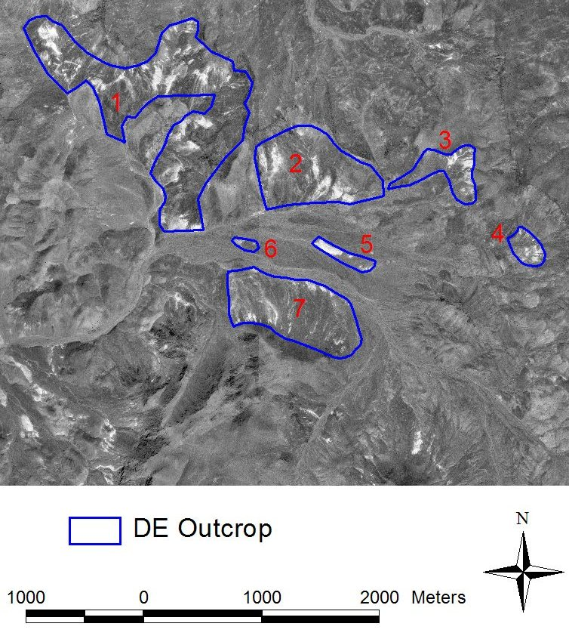
Figure 1. The seven largest outcrops of D.E. mapped on the Coaldale NE Digital Ortho Quarter Quads.
Each of the seven polygons representing an outcrop of D.E. was treated as a right triangular solid. This assumption assures that the subsequent volume (tonnage) calculation is a minimum, or lower bound, because lacustrine D.E. deposits in Nevada are known to have significant horizontal continuity.
The seven polygons were used as a layer on the 7.5’ Coaldale NE Digital Raster Graphic (DRG) image (Figure 2). This DRG is GIS-compatible and has a contour interval of 20 feet. A given polygon typically had some parallelism with a high and low contour on the DRG. The elevation difference between the high and low contours was used as the length of the vertical side of a right triangle. The horizontal distance between the high and low contours was used as the length of the horizontal side of a right triangle and the area of the triangle was calculated [(area of right triangle) = (0.5) * (length of vertical side) * (length of horizontal side)].
The length of the horizontal side of the right triangles was measured perpendicular to the contours on the DRG. By measuring the length of a polygon parallel to the contours, the length of the right triangular solid was determined. Multiplying the length of the right triangular solid by the area of the right triangle gave the volume of the right triangular solid. Table 1 shows lengths and volumes for each of the seven polygons. The total volume calculated from the seven polygons was 6 x 10⁹ feet³.
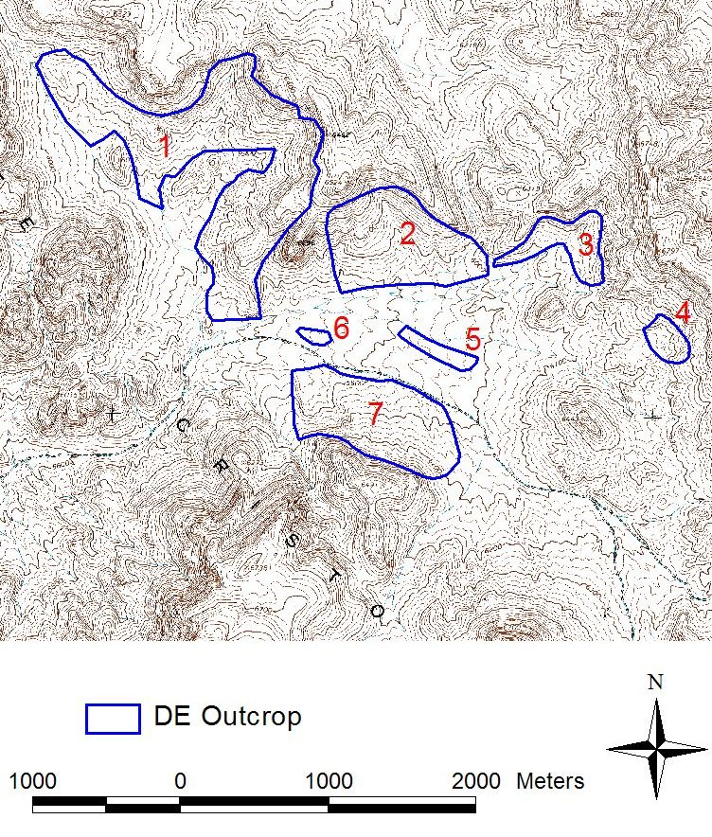
Figure 2. Polygons representing the largest D.E. outcrops overlain on the Coaldale NE 7.5’ Digital Raster Graphic map.

D.E. Polygon | Volume (10⁶ ft³)
1 | 3110
2 | 1500
3 | 90
4 | 45
5 | 20
6 | 35
7 | 1200
Total | 6 x 10⁹ ft³
Table 1. Calculated volume (ft³) of each of the seven D.E. outcrops.
Diatomaceous Earth is a depositional product of fresh water embayments of Pliocene age. In Nevada it has been observed in stratigraphic layers up to 300 feet in thickness, continuing for hundreds of feet horizontally. In this depositional context, the 6 x 10⁹ feet³ calculated by the triangular solid method assumes a near-impossible stratigraphic termination. Based on observations of D.E. in other parts of Nevada, increasing the 6 x 10⁹ feet³ volume by at least 100%, to 12 x 10⁹ feet³, is a more accurate estimate. This adjusted value is still a conservative estimate and represents a minimum volume of D.E.
A value for the tonnage was determined by multiplying the volume of the right triangular solids by the bulk density of the D.E. (32 lbs/ft³). The total tonnage value calculated in this analysis was 192 x 10⁶ tons.
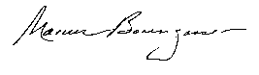
____________________________

Marcus Borengasser, Ph.D.

Marcus Borengasser, Ph.D.
3490 Kent Drive
Melbourne, FL 32935
321 242-6336
MarcusB48@hotmail.com

Professional Summary

Professional Geologist/Spatial Data professional with more than 20 years of experience. Additional experience with hyperspectral remote sensing, image analysis, and geographic information systems (GIS), and all aspects of geoscience, plus university-level instructing.

Experience

Consultant
Professional Geologist. Geologic mapping using remote sensing and GIS technology

University College, London
Research Scientist: Modeling sea level change with satellite altimeter data

University of Nevada, Reno
Laboratory Manager: Remote sensing laboratory

University of Nevada, NASA/JPL
Co-Investigator: Shuttle Imaging Radar-B experiment

University of Nevada, CNES
Co-Investigator: SPOT/PEPS project

Nevada Dept of Minerals
Primary Investigator: Mineral appraisal project

Chevron USA
Petroleum Geologist: CA/Santa Barbara Channel

Education

- M.S., Computer Science, Florida Institute of Technology, Melbourne, FL
- Ph.D., Geology, University of Nevada–Reno, NV
- M.S., Geology, University of Arkansas–Fayetteville, AR
- B.S., Geology, University of Arkansas–Fayetteville, AR

computer skills

- Programming languages: C/C++, SQL, VBA, and proficiency with MATLAB
- Geographic information system software: ArcView 9.2, Arc/Info, Spatial Analyst, Stereo Analyst
- Image processing software: ENVI, ERDAS Imagine

Publications

Borengasser, M., Forensic Image Processing, McGraw-Hill, in preparation.

Borengasser, M., Hungate, W. and Watkins, R., Hyperspectral Remote Sensing with Applications, CRC Press, 2007.

Diatom Hill Project, Esmeralda County, Nevada

A field review was conducted of American Diatomite’s “Diatom Hill Project” on October 4, 2008 with Darvin Wade. The aerial extent of the bedded diatomite unit was verified along strike and dip at several locations within the claim block. In addition it was noted that the diatomaceous unit is exposed over a wide area along the west side of the Monte Cristo Range. Exploration potential beyond the identified Indicated Mineral Resource of 192 million tons identified in the Borengasser report is excellent.

Ownership:
The project consists of 35 unpatented placer mining claims totaling 1700 acres. The claims are located in Sections 25 and 26, Township 4 North, Range 37 East, Esmeralda County, Nevada. American Diatomite owns a 100% interest in the claim group and has paid all annual assessment fees to the county and the BLM.

History:
The diatomite occurrences have been known since the early 1920s. They are first mentioned in a 1923 regional report on Nevada mineral resources by F. C. Lincoln. Historic exploration within the existing project area is evidenced by a series of small pits, tunnels, and declines. Shu Fly diatomite deposit located west of American Diatomite’s holdings has seen minor production. The Nevada Bureau of Mines and Geology reports that the diatomite deposits are hosted in Miocene to Pliocene Age sediments. The Basalt diatomaceous earth deposits located approximately 25 miles west of Diatom Hill were operated from 1944 to mid 1970s by GREFCO. They are hosted in a similar geologic setting as Diatom Hill. The United States Geological Survey has mapped the Monte Cristo Range at a scale of 1 inch equals 1 mile. Their work identified extensive sedimentary diatomite occurrences in the mid-Miocene McLeans Formation.

Previous Exploration Activity:
As mentioned above prospecting of the diatomite has occurred since the 1920s with limited production. American Diatomite has been in the process of evaluating the property since 2002. Their work to date has been to sample outcroppings and conduct shallow drill holes to collect samples for geochemical analysis. Marcus Borengasser completed a mineral appraisal evaluation based American Diatomite’s and public domain information.

Geology:
Diatomite is a chalk-like, soft, friable, earthy, very fine grained, siliceous sedimentary rock comprised of fossilized diatom remains. Diatomite often has a light color (white if pure, commonly buff to gray in-situ, and rarely black). It’s extremely light because of its low density and high porosity, and essentially chemically inert. All of this matches the Diatomite member of the McLeans Formation, the host unit at the Diatom Hill Property.
The Tertiary, Miocene age McLeans Formation ranges in age from 15 to 18 million years ago. This sedimentary formation is a series of siltstone, shale and sandstone that contain interbedded diatomite. Average thickness of the bedded diatomite is approximately 100 feet. The unit can locally be up to 300 feet thick. The McLeans Formation is typical of most fresh water diatomite deposits in the Western United States that formed during the Miocene and Pliocene. The Miocene climate in the region was fairly mild and wet gradually becoming drier in the late Miocene. Lakes formed throughout the western United States during this period under numerous different geologic conditions. The McLean Formation formed in a freshwater lake setting with Diatom blooms occurring over several million years. Diatom growth and formation relies on an influx of silica and nutrients. Silica is needed to form their skeletons. Streams carried silica and important nutrients such as phosphorus into the lakes. Volcanic ash, produced from nearby and regional eruptions lands on and settles through a lake and can react with the water, releasing silica. Diatomite deposits form from an accumulation of amorphous hydrous silica cell walls of dead diatoms in this fresh water setting. These microscopic single-cell aquatic plants (algae) contain an internal, elaborate siliceous skeleton consisting of two frustules (valves) that vary in size from less than 1 micrometer (µm) to more than 1 millimeter in diameter, but are typically 10 to 200 µm in diameter. The frustules have a broad variety of delicate, lacy, perforated shapes, including cylinders, discs, feathers, ladders, needles, and spheres.
The McLeans Formation is situated below the “Blair Junction sequence”. This sequence includes three major units: an upper and lower andesite and dacite flows and associated sedimentary and intrusive with a medial tuff unit composed of lithic and pumice-rich, vitric, nonwelded, pyroclastic tuff. The Gilbert Andesite underlies the McLeans Formation. It forms massive resistant outcrops capping many of the ridge lines in the Monte Cristo Range. The formation consists of andesite and trachyandesite flows and volcanic breccia. The striking white color of the diatomite sandwiched between the two darker volcanic formations make for easy field and air photo identification.
The USGS has mapped the McLeans diatomite over 3.5 miles of strike at an average width of a ½ mile. American Diatomite’s claim block is central to this zone. The USGS also identified several species of the Melosira diatoms in samples taken immediately west of the claim block. The potential for the diatomite unit extending under volcanic cover or a thin veneer of recent float is excellent.

Geochemistry:
Sampling conducted by American Diatomite and Marcus Borengasser were assayed by ALS Chemex in Reno, Nevada and Huffman Laboratories in Golden, Colorado. Results from both labs average 89% SiO2.

Exploration Potential:
The potential to increase the existing Indicated Mineral Resource beyond 192,000,000 tons is excellent. An Inferred Mineral Resource in the diatomite bearing McLean Formation beneath the Blairs Junction volcanics could exceed 232,000,000 tons as per the Borengasser report. The SiO2 content of the later Inferred Mineral Resource is not known but is probably similar to the Indicated Mineral Resource. Detailed sampling and mapping would be required to verify the economic potential of the diatomite unit.

Mineral Resource:
American Diatomite Controls an Indicated Mineral Resource of 192,000,000 tons of diatomite with an average grade of 89% SiO2 at their Diatom Hill Project. The USGS recently released the 2007 Minerals Yearbook for Diatomite. This report was not available when Borengasser completed his review of the property. The USGS report gives an average unit value of $237 per ton, an increase of 8% over 2006. Unit value for diatomite fillers is $438 per ton and increase of 11% over 2006. The only negative is in the price of specialized uses, dropping to $230 per ton. Using the average production cost of $40 per ton the value of the indicated resource is between $35.5 to $76.4 billon dollars. Exploration potential to add significant tonnage to the indicated resource is excellent.
I only reviewed the data supplied by American Diatomite which includes the report by Marcus Borengasser. This was combined with observations from the field review conducted with Darvin Wade and public domain information acquired from the Nevada Bureau of Mines and Geology and United States Geologic Survey. All conclusions were drawn from these information sources.

Recommendations:
Consolidate claim block and complete a claim location map. Combine this with public domain geologic mapping and field mapping and expand claim block to cover surface exposures of diatomite. Use this same base map and plot all available geochemical sample locations. This would establish a preliminary silica grade contour map. It would aid in eventual identification of mineable resources and tonnages. With the consolidation of the claim block keep in mind that access has to be protected. A third party can’t acquire adjacent ground and force a negotiation in order for American Diatomite to establish mine access to the resource. Also if exploration to establish additional tonnage is an objective then the ground should be acquired before any potential competition does.
Current claim block covers approximately 1700 acres, slightly over 1 square mile. The claims need to be contiguous so a third party can’t acquire any holes or open ground in the claim block. Surface outcrops of diatomite and secure access would require further field evaluation prior to expanding the current land position. At a minimum, a two or three fold increase from the current 35 claims would be required.

Russell W. Allen
Professional Registered Geologist
Q.P.

RUSSELL W. ALLEN
1585 Satellite Drive
Sparks, Nevada 89509
(775) 233-8327
dancnbear @charter.net
____________________________________________________________________

SUMMARY

Thirty three years of extensive experience in minerals exploration, fifteen of that in senior management positions. This includes preparing and making budget presentations to management, securing bids, negotiating contracts, and acquiring the necessary permits. I have worked closely with state and federal regulators to secure permits and resolve conflicts. This required hands on management with drill and road contractors in order to insure compliance.
AFFILIATIONS

Geological Society of Nevada
Society of Economic Geologists

PHOTOS REPRESENT ONLY A SMALL AREA OF TWO SQUARE MILES OF WHITE SPECIALIZED AMORPHOUS SILICA.
